Ideation Phase
Empathize & Discover

Date | 31 January 2025
Team ID | 6ab3d8050fc666a751b367a2
Project Name | AI StudyBuddy
Maximum Marks | 4 Marks

Empathy Map Canvas
Project Title: AI StudyBuddy
An empathy map is a simple visual tool that helps understand students’ behaviours, thoughts, feelings, and needs. It is used to identify the challenges students face while managing their studies and daily activities.
The Empathy Map Canvas for the AI StudyBuddy with Weather API project helps the development team understand students’ problems from their point of view. It focuses on study planning, AI-based learning assistance, task management, and weather updates.
Creating this map helps identify students’ goals, difficulties, and expectations. It also supports the development of a user-friendly application that combines AI study assistance and real-time information to make daily planning easier.

Example:
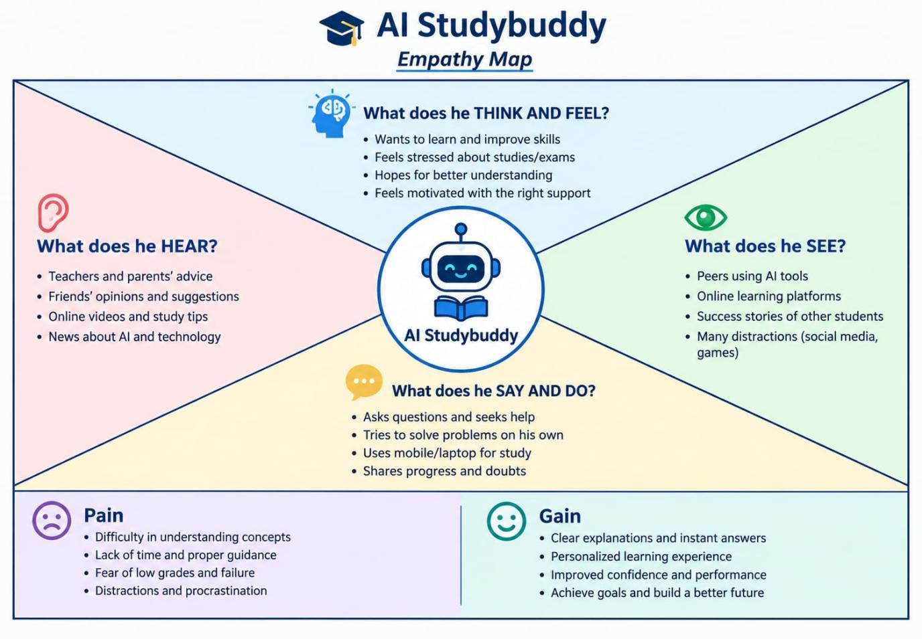

Example:

AI-Based Study Planning and Learning Assistance Application
